**Problem Statement:** Create a system for drawing a complete polygon for any small asset (i.e Assets developed during MGNREGA, PMAYG schemes) by knowing 3 coordinates along with the length and width.

**Organization Name:** Ministry of Rural Development.

**Methodology:**

1. First we have capture the area on the map on which we have to work. Then we have drawn the one polygon and inside that we have marked the specific building or plot using a rectangle.

2. As now by given 3 points of latitude and longitude to us and by using this 3 points we can draw rectangle. (all 3 points are along length and width).

3. Now we have removed the extra area from the image or map.

4. Now for transforming the map we will be using image classification algorithm (Segment) in Matlab.

5. By following this all processes we will get an ultimatum to convert this all thing as a software by the government.

6. We can get it by two ways: One from python script and Arcgis and Another one using Matlab.

7. It is generally done by technique called In the segmentation using Canny's Method.

8. Now let’s move towards the code for the segmentation process:

1. First we will read the image and show it.An image is created by using RGB (means it is created by combining the intensity of red, blue and green color).

2. Now after reading this color image we will now convert it into the Gray Scale image i.e the image will be converted into black and white (means the part which is more reflected will turn in white and which is not or less reflected will be turned into grey or black shade in the image).

3. Now by using cannys method we will detect the image of a building which is inside the rectangle.And here we see that we are getting the proper shape of an building which is there in the rectangle.

4. As it is all depends on the clear visibility of the image on the map. If it is more clearly visible then it will give the accurate shape of the building or plot.

5. Now we will process the image and convert it back to RGB image from Greyscale image. And hence we have got the final and accurate irregular shape of the building that we have choosen.

**Functions used are:**

1. **imread ():** it used to read the imported RGB image.

2. **imshow():** It is used to display the image.

3. **rgb2gray ():** converted the imported RGB image to grayscale image.

4. **edge ():** It is used to detect the edges of the image.

5. **imbinarize ():** It is used to binarizing the grayscale image.

6. **bwlabel ():** labeling the objects in the in the binarized image.

7. **label2rgb ():** converting the labeled objects to RGB image.

1. **Created polygon using latitude and longitude.**

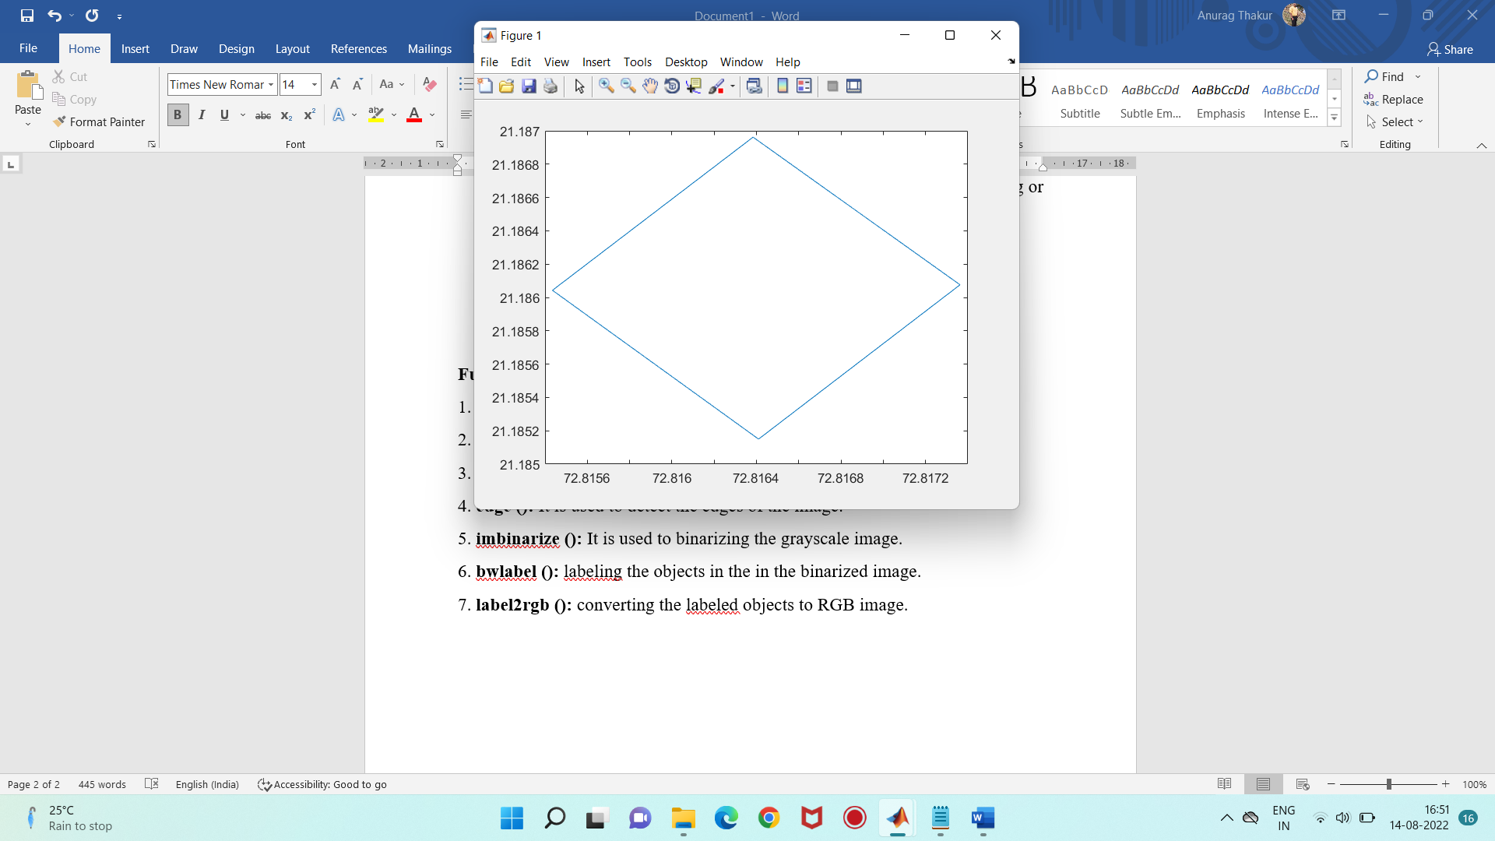

1. **Original Image:**

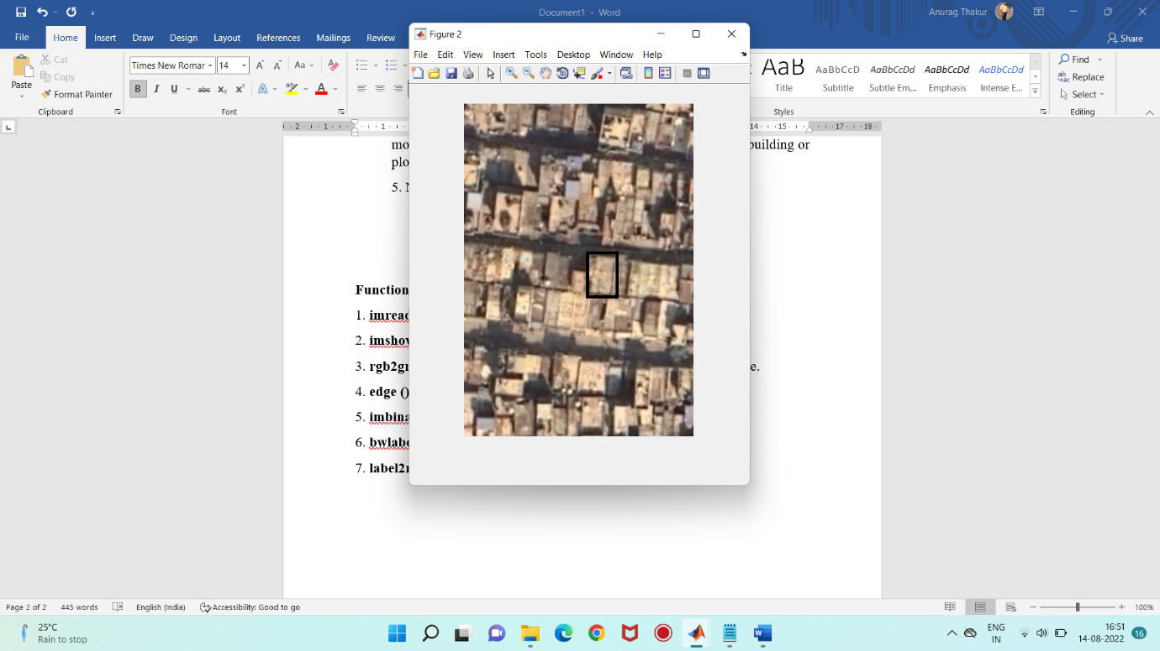

1. **RGB to Greyscale Image:**

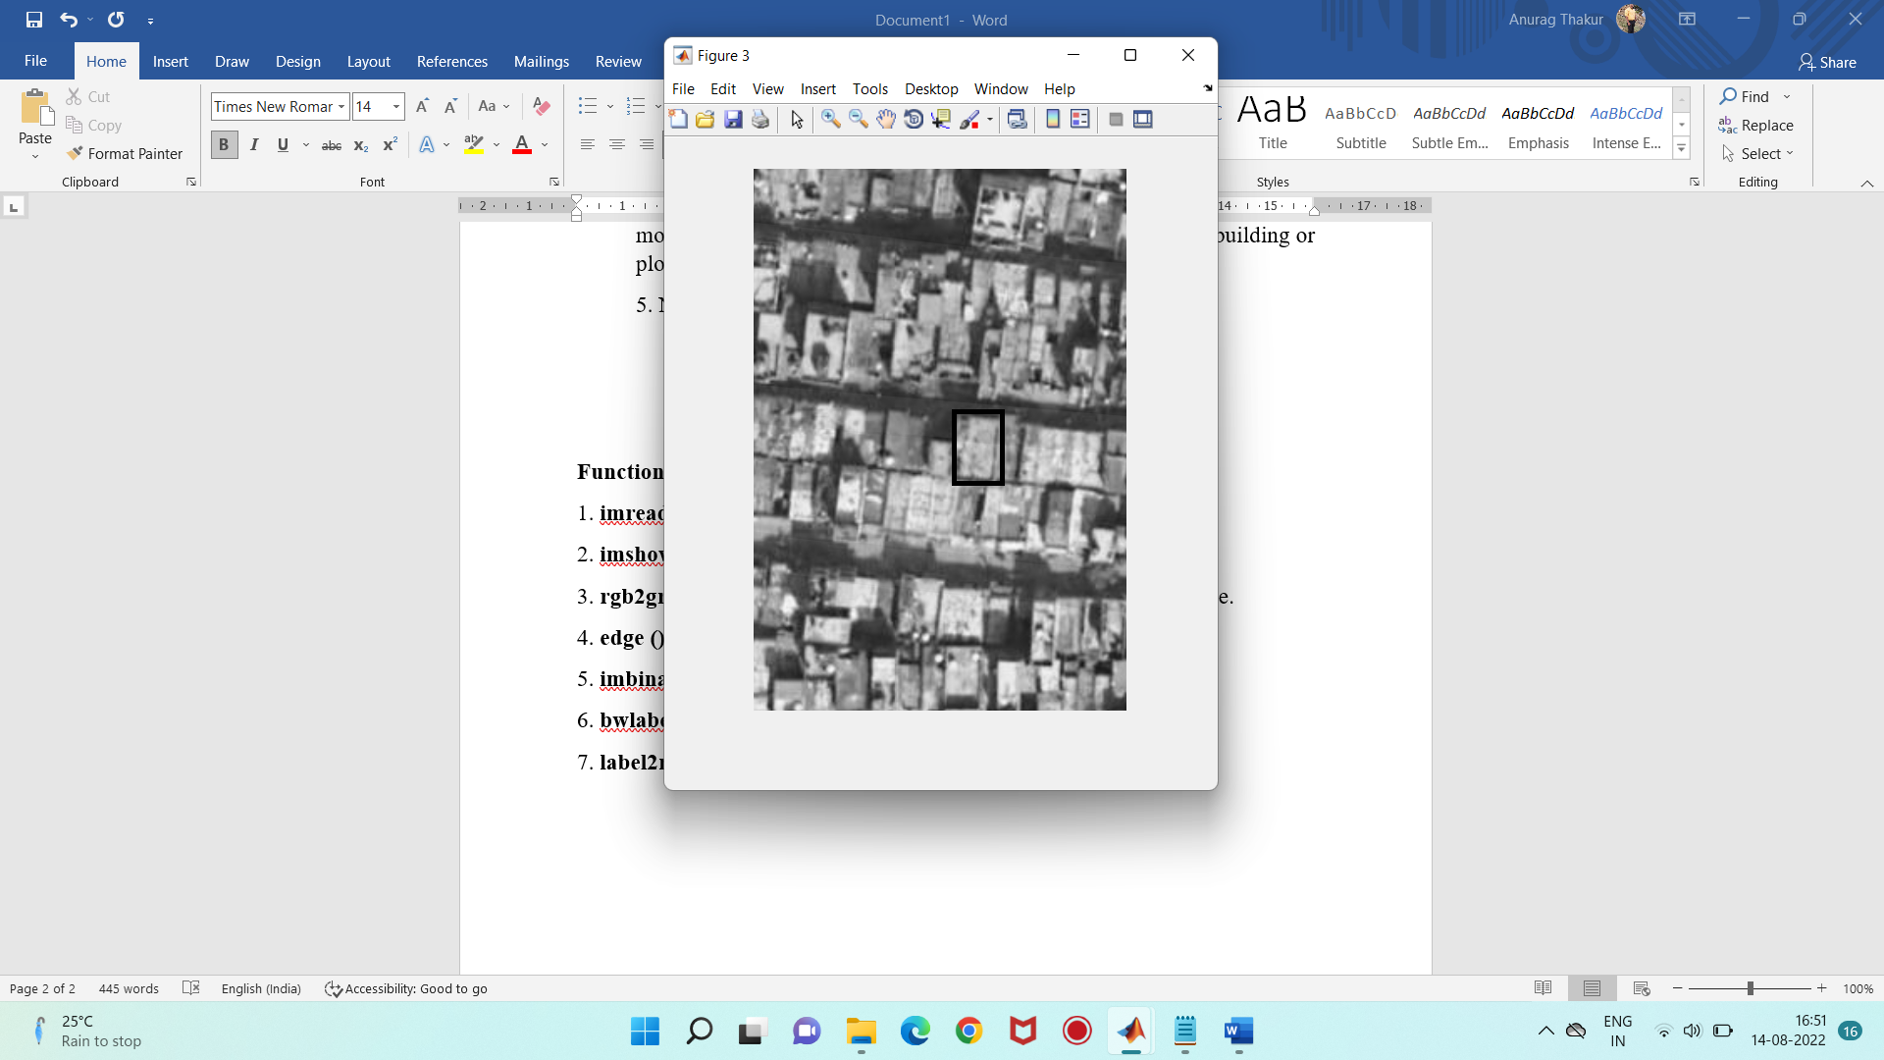

1. **Edge detection using Prewitt method:**

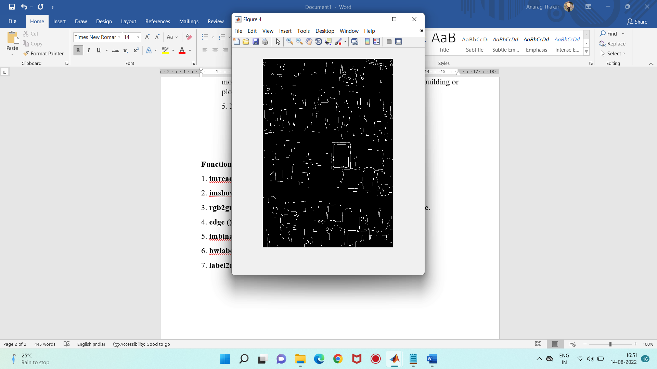

1. **Edge detection using log method:**

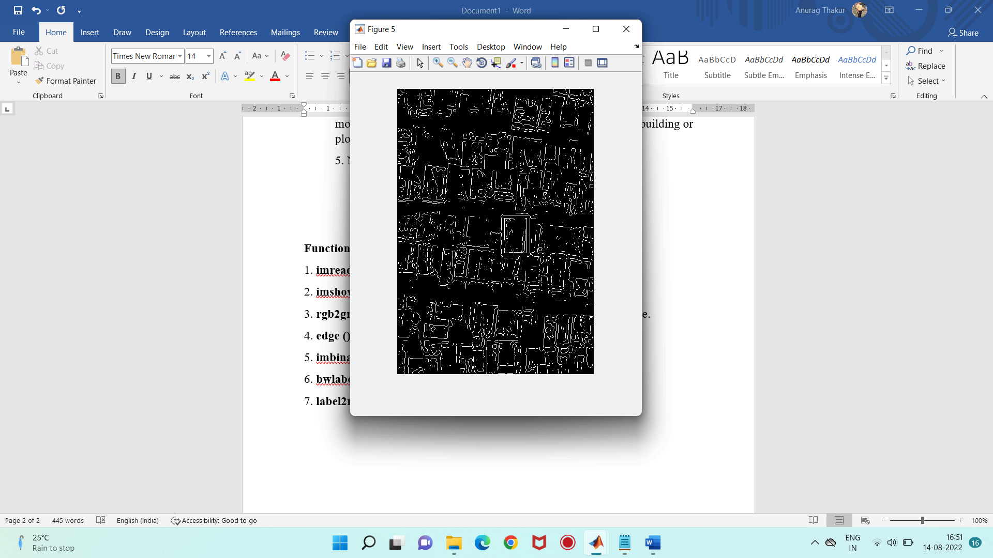

1. **Edge detection using canny method:**

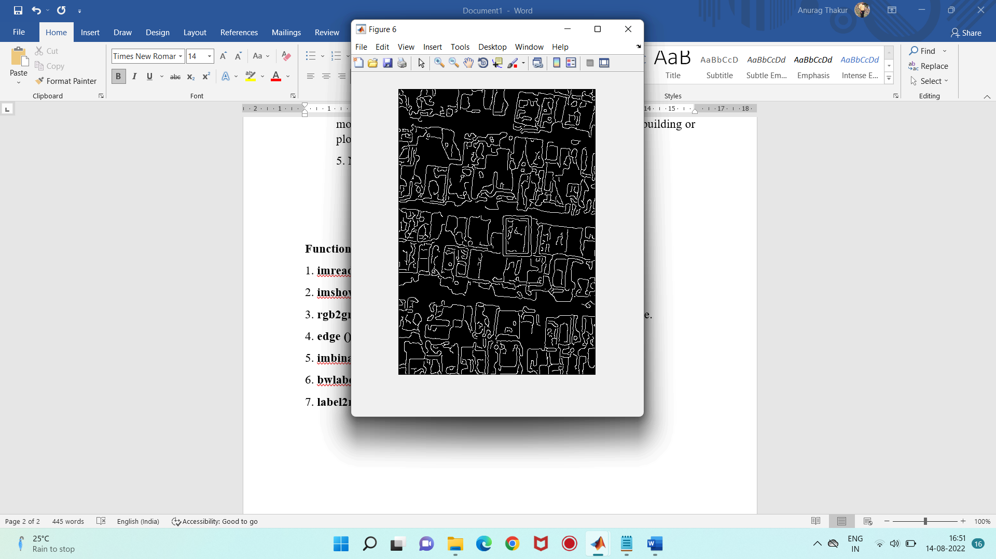

1. **Binarizing the Greyscale image:**

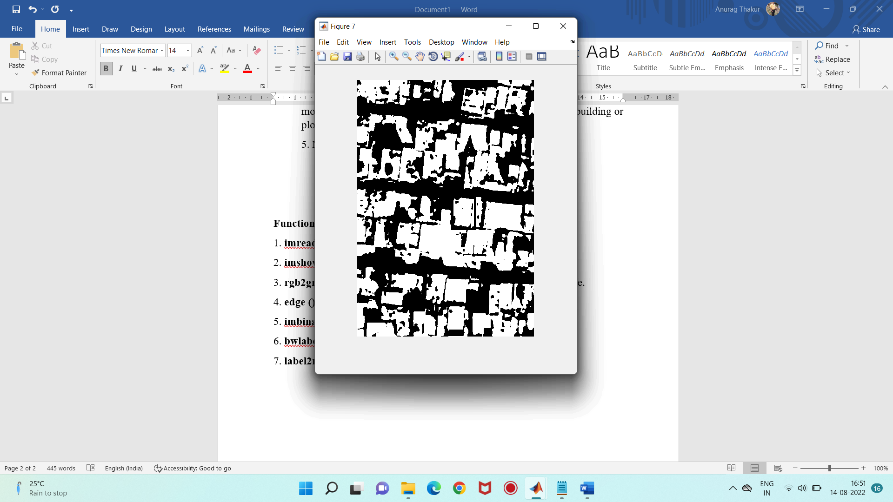

1. **Converting Greyscale image to RGB image:**

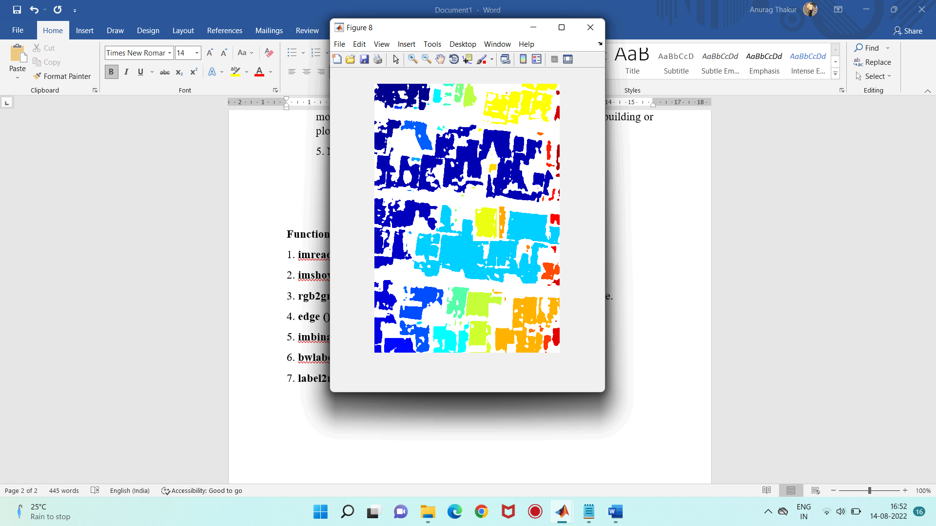

Q. What is segmentation ?

Image segmentation is an extension of image classification where, in addition to classification, we perform localization. Image segmentation thus is a superset of image classification with the model pinpointing where a corresponding object is present by outlining the object's boundary.

Q. Need for image segmentation ?

Segmentation is an important stage of the image recognition system, because it extracts the objects of our interest, for further processing such as description or recognition. Segmentation of an image is in practice for the classification of image pixel [3]. Segmentation techniques are used to isolate the desired object from the image in order to perform analysis of the object.

Q. What is Edge segmentation or detection ?

Edge segmentation, also called edge detection, is the task of detecting edges in images.

From a segmentation-based viewpoint, we can say that edge detection corresponds to classifying which pixels in an image are edge pixels and singling out those edge pixels under a separate class correspondingly.

Edge detection is generally performed by using special filters that give us edges of the image upon convolution. These filters are calculated by dedicated algorithms that work on estimating image gradients in the x and y coordinates of the spatial plane.

An example of edge detection using the Canny edge detection algorithm, one of the most popular edge detection algorithms is shown below.

Q. Converting RGB to Greyscale image ?

Grayscale is the simplest model since it defines colors using only one component that is lightness. The amount of lightness is described using a value ranging from 0 (black) to 255 (white).

On the one hand, grayscale images convey less information than RGB. However, they are common in image processing because using a grayscale image requires less available space and is faster, especially when we deal with complex computations.

Advantages:

To store a single colour pixel of an RGB colour image we will need 8*3 = 24 bits (8 bit for each colour component), but when we convert an RGB image to grayscale image, only 8 bit is required to store a single pixel of the image. So we will need 33 % less memory to store grayscale image than to store an RGB image

Grayscale images are much easier to work within a variety of task like In many morphological operation and image segmentation problem, it is easier to work with single layered image (Grayscale image ) than a three-layered image (RGB colour image )

It is also easier to distinguish features of an image when we deal with a single layered image

Gray scale conversion

is also a vital part of image processing. RGB or color

information has a 3 dimensional property which makes

signal processing so much bulky and heavy to remove

this drawbacks gray scale conversion is necessary.

**Binarizing the image:**

Image binarization is **the process of taking a grayscale image and converting it to black-and-white**, essentially reducing the information contained within the image from 256 shades of gray to 2: black and white, a binary image.